From: Gayle Harrison [mailto:gayle.harrison@sympatico.ca]
Sent: Friday, June 28, 2013 10:55 AM
To: 'Brian.McHattie@hamilton.ca'
Cc: 'mayor@hamilton.ca'; 'Jason.Farr@hamilton.ca'; 'Maria.Pearson@hamilton.ca'; 'Lloyd.Ferguson@hamilton.ca'; 'kwynne.mpp.co@liberal.ola.org'; 'mchan.mpp.co@liberal.ola.org'; 'kevin.finnerty@ontario.ca'
Subject: GORE PARK BUILDINGS

Dear Councillor McHattie:

This letter is directed to you as my representative on City Council. I am very concerned that City Council has not designated all of Gore Park.
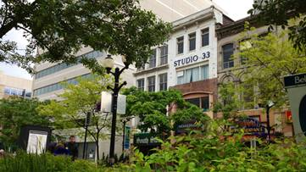

The motion introduced by Councillor Farr at GIC last week and to be voted on at the GIC meeting on July 8 is, in my opinion, and that of many citizens, not a compromise but a cop-out. (The motion of which I’m sure you are aware is below.)

The motion: Whereas, there has been considerable concern and some confusion as it relates to the pending possible demolition of two Gore District buildings related to a future development in the area, and;

Whereas, Culture and Heritage Staff are currently working on a report and have assured Council of a report back on the Downtown Heritage Buildings Inventory, but not until the fourth quarter as it relates to buildings that qualify for the Heritage Register in the downtown area (properties on the Register are protected for 60 days should a demolition permit be applied for), including the Gore District, and;

Whereas, despite the staff project, concern continues that the integrity of the Gore District may be lost in the interim, should additional demolition permits be applied for, noting that properties currently part of the staff project are not currently protected from demolition.

Therefore, be it resolved; That all properties in the Gore District listed on the City's inventory of heritage buildings, with the exception of 24 and 28 King Street East previously granted a demolition permit, be added to the Register.

The citizens of Hamilton have lost far too many heritage buildings. I expect our councillors to provide leadership and designate Gore Park. By the time council approves placing any buildings on the registry it will be too late to prevent demolition of the buildings in the Gore or any building that is not designated. Furthermore, placing buildings on the registry only alerts council that a demolition permit has been applied and the review time is very limited. Protection is via Designation. By law, the Ontario Heritage Act allows City Councils to designate a building without owner consent. Minister of Culture, Michael Chan, and his ministry recognize the unique importance of Hamilton's Gore Park; Minister Chan awaits and expects Hamilton City Council to show leadership and designate all the buildings in Gore Park.

Rather than approve the above motion that goes to GIC July 8, I await your intelligent response - DESIGNATE all the buildings in Gore Park.

I hope you have toured Gore Park and reviewed the walking tour brochure of Gore Park developed in 1997 by Heritage Hamilton Foundation and the City of Hamilton thanks to a summer student grant. Thankfully, the streetscape has changed little since then. We citizens trust our politicians to do what is best for Hamilton. Designation is the right thing to do.

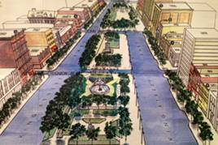
The Heritage Hamilton Foundation 1997 brochure

On June 18 2013, Paul Wilson wrote:
Two years ago, the owner knocked down a narrow century-plus building on King East, south side of the street, across from the fountain. They made the place disappear fast. They’ve been asked back, this time to take care of the buildings right next door, No. 24 and No. 28. They too are old, from 1876 and 1874 respectively. When they went up, Canada still hadn’t celebrated its 10th birthday. Alexander Graham Bell had just made his first phone call. A train had just crossed the continent in a blistering 84 hours.
So, yes, those buildings are from another time. And the owners say that time has passed. They declare that the structures are beyond repair.
Last fall, David Blanchard and partners announced plans for a big development on that south side of Gore Park. They now own most of the block bounded by King, James, Main and Hughson and propose to fill it with a complex that would include retail, commercial and condos.

One sure thing - When pressed for a value of this project, they put it at $120 million. But they admitted that was a rough estimate indeed. There was much yet to be worked out.
Of one thing, they were sure. They said five old buildings had to go to make way for this big plan.
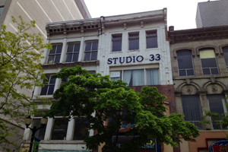
When these buildings went up, Canada was but a child. (Paul Wilson CBC)

Many objected to losing all that history, and five months ago Blanchard sat down with councillors Jason Farr and Brian McHattie. A compromise was reached. Three structures would be saved – Numbers 18, 20 and 22. They’re the stone-fronted 1840s Kerr buildings. The front third is to be turned into condos. The rear will be demolished.

But the other two buildings are a treat to gaze up at too. CBC Hamilton asked Blanchard last month if he’d be open to saving at least the facades there. He said yes – but the expense of doing that would have to come from the city, and he would need to hear fast.
Well, time’s up. “No one came forward to say anything about it,” he said yesterday. “There were no monetary offers.”
~~~~~~~~

I look forward to your response to my email and your response to designate.

Sincerely,

Gayle Harrison
209 Parkview Drive
Hamilton, Ontario, L8S 3Y4
Secretary-Treasurer, Heritage Hamilton Foundation

